**FINAL REPORT**

**Capstone Project - The Battle of Neighbourhoods**

Srijan Gupta

**Introduction:**

The City of New York, is the most populous city in the United States. It is diverse and is the financial capital of USA. It is multicultural. It provides lot of business opportunities and business friendly environment. It has attracted many different players into the market. It is a global hub of business and commerce. The city is a major centre for banking and finance, retailing, world trade, transportation, tourism, real estate, new media, traditional media, advertising, legal services, accountancy, insurance, theatre, fashion, and the arts in the United States.

This also means that the market is highly competitive. As it is highly developed city so cost of doing business is also one of the highest. Thus, any new business venture or expansion needs to be analysed carefully. The insights derived from analysis will give good understanding of the business environment which help in strategically targeting the market. This will help in reduction of risk. And the Return on Investment will be reasonable.

**Problem:**

A restaurant is a business which prepares and serves food and drink to customers in return for money, either paid before the meal, after the meal, or with an open account. The City of New York is famous for its excelllent cuisine. It's food culture includes an array of international cuisines influenced by the city's immigrant history.

In this project I want to find the answers of the below stated questions which is based on Indian Cuisines and Indian Restaurants :

List all great Indian Restaurants that are currently operational in New York City

1.Which are the best localities with great Indian food

2.Which areas lack Indian restaurants

3.What are the top Indian Restaurants in New York

**Data Section:**

New York City's demographics show that it is a large and ethnically diverse metropolis. With its diverse culture, comes diverse food items. There are many restaurants in New York City, each belonging to different categories like Chinese, Indian, and French etc.

For this project we need the following data:

* New York City data that contains list Boroughs, Neighbourhoods along with their latitude and longitude.
* Data source : <https://cocl.us/new_york_dataset>
* Description: This data set contains the required information. And we will use this data set to explore various neighbourhoods of New York City
* Indian restaurants in each neighbourhood of New York City.
* Data source : Foursquare API
* Description: By using this API we will get all the venues in each neighbourhood. We can filter these venues to get only Indian restaurants.
* GeoSpace data
* Data source : <https://data.cityofnewyork.us/City-Government/Borough-Boundaries/tqmj-j8zm>
* Description: By using this geo space data we will get the New York Borough boundaries that will help us visualize choropleth map.

**Methodology:**

1. We begin with loading New York data from <https://cocl.us/new_york_dataset>
2. Then we pre-processed and created data frame from the data with columns Borough, Neighbourhood, Latitude, Longitude

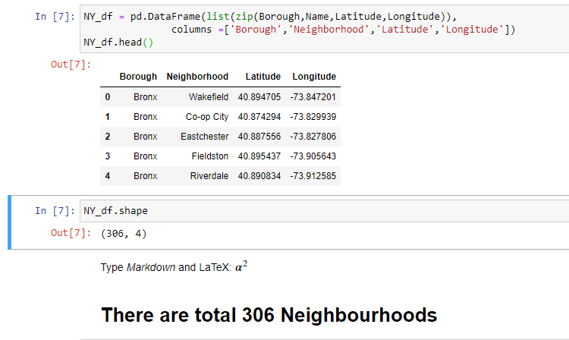

1. After that using the FourSquare API we get the details of all the Indian Restaurant present in all the neighbourhoods and store them.

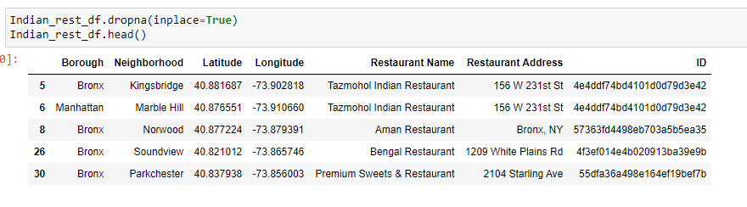

1. We get the neighborhoods which do not have any Indian Restaurants.

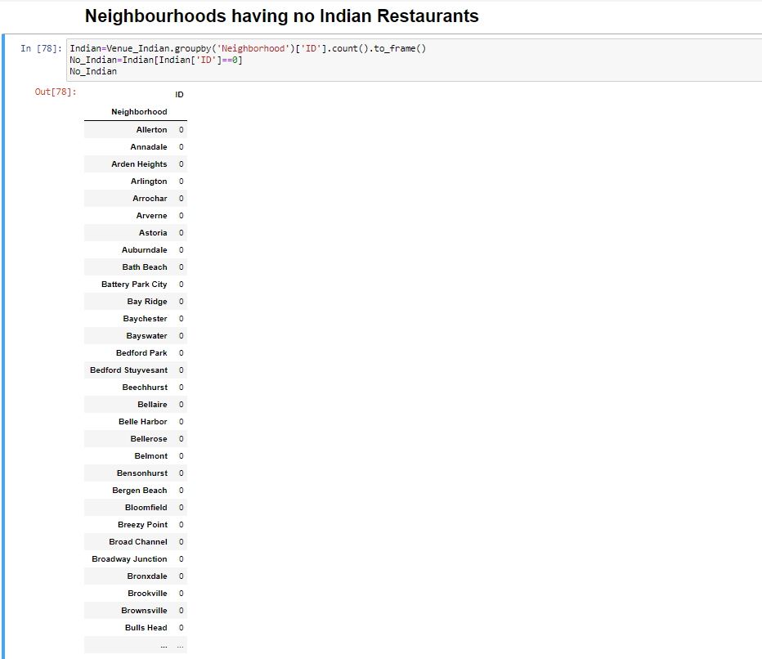

1. We then get the details such as Ratings, Price, Like of each Indian restaurant using FourSquare API from the venue.

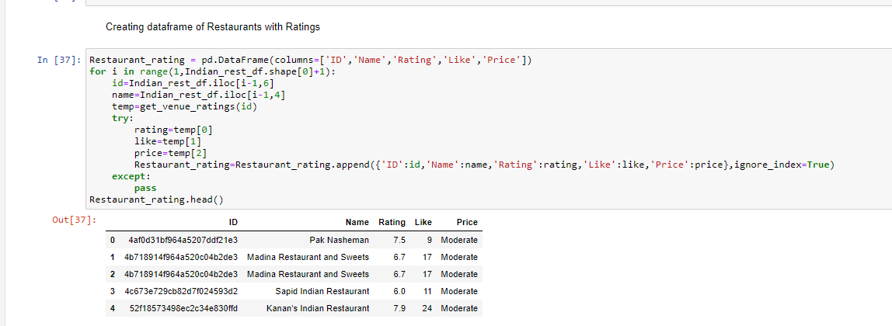

1. We then sort the restaurant data based on Rating to get the highest rated Restaurant in New York.

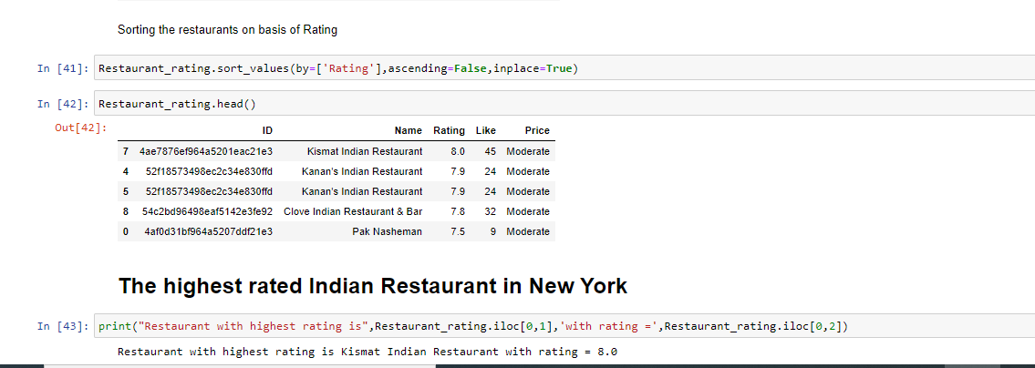

1. We get the average rating of the restaurant of each neighborhood, which gives the best location to have Indian cuisine.

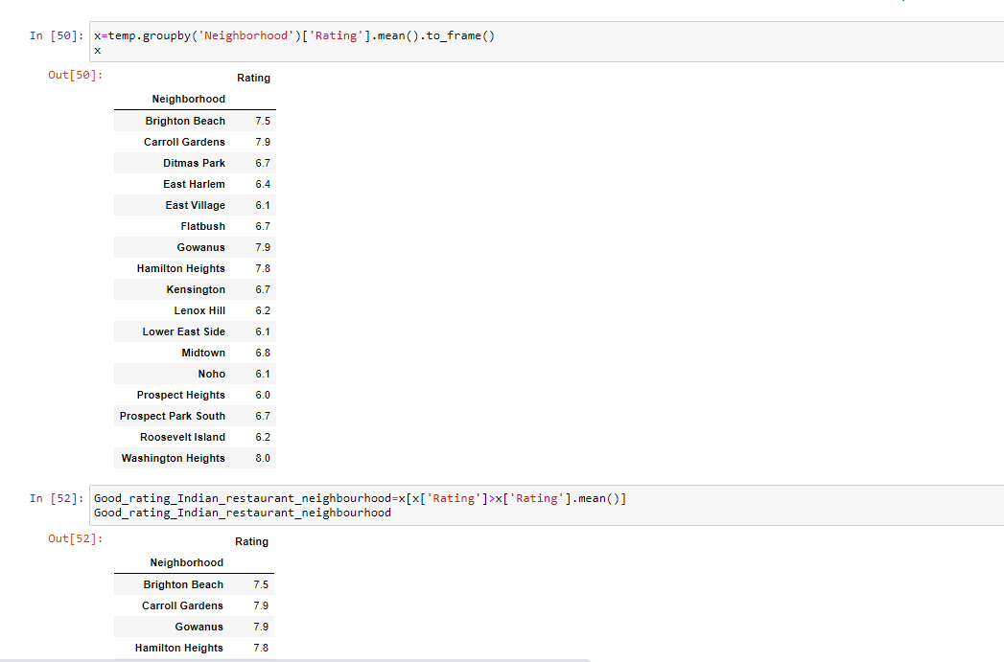

**Result:**

So now we can answer the questions asked above in the Questions section:

1.Which are the best localities with great Indian food

Brighton Beach, Carroll Gardens, Gowanus, Hamilton Heights, Washington Heights

2.Which areas lack Indian restaurants

Neighbourhoods like Allerton,Annedale etc. Total 226.

3.What is the top Indian Restaurants in New York

Kismat Indian Restaurant in Washington Heights

**Conclusion:**

There is always room for improvement and hence the above solution I have provided can also be improved for best results depending upon the data we have.